
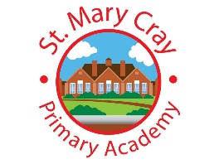
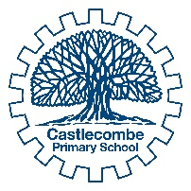

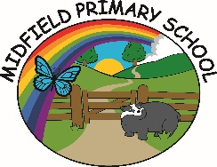


The Spring Partnership Trust

Home Learning Overview:
Year |Group: 2
Week Beginning: Monday 5th October
Subject | For week beginning:
Subject | - Resources needed | - Guidance (Part of home learning)
Maths | BBC Home Learning | Follow the lessons on place value on the White Rose  https://whiterosemaths.com/homelearning/year-2/week-1/  You can also explore the lessons on the BBC Home Learning website:  https://www.bbc.co.uk/bitesize/articles/z2k3p4j
Reading |  | Reading should happen daily for 15-20 minutes.
Spelling | Spelling Sets – on website | Your child can choose which spellings they wish to complete using their spelling sets (KS2). Children in KS1 will have spellings linked to their phonics learning sent on dojo.
Grammar | Year 2 – Grammar | Focus: Questions  Watch the video and write some of your own questions using question marks.  https://www.bbc.co.uk/bitesize/topics/zrqqtfr/articles/z2xdng8
English | BBC Home Learning | Explore the lessons on the BBC Home Learning website:  https://www.bbc.co.uk/bitesize/collections/year-2-and-p3-english-topics/1
Times tables | See individual school plans | Practice your 2 and 10 times tables please
Science | Year 2 – Animals including humans. | Lesson 6 - WALT: investigate the effects of exercise on our bodies  Carry out the following forms of exercise:  1 minute of star jumps  1 minute jogging on the spot  1 minute push ups  After each exercise think about how your body feels. What changes do you notice? Are you sweaty? Out of breath? Make a note on how exercise has effected your body.
History/ Geography | Year 2 Geography – Orienteering. | Lesson 4 - WALT: Orienteer  Watch the video about orienteering. Create a map of your room and then hide 3 items and mark on your map where they are hidden. Can a family member use you map to find them?  https://www.bbc.co.uk/sport/get-inspired/24066826
RE | Year 2 RE – Christianity  - PPT on class page | Lesson 6 – WALT Identify the features of a church  Visit this virtual tour of Canterbury Cathedral. What features can you spot that we have looked at in class? https://www.canterbury-cathedral.org/visit/information/tour/

