
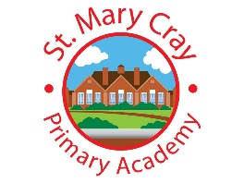


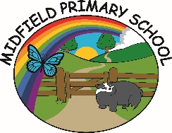


The Spring Partnership Trust

Home Learning Overview:
Year |Group: 2
Week Beginning: Monday 12th October
Subject | For week beginning:
Subject | - Resources needed | - Guidance (Part of home learning)
Maths | BBC Home Learning | Follow the lessons on place value on the White Rose  https://whiterosemaths.com/homelearning/year-2/week-1/  You can also explore the lessons on the BBC Home Learning website:  https://www.bbc.co.uk/bitesize/articles/z2k3p4j
Reading |  | Reading should happen daily for 15-20 minutes.
Spelling | Spelling Sets – on website | Your child can choose which spellings they wish to complete using their spelling sets (KS2). Children in KS1 will have spellings linked to their phonics learning sent on dojo.
Grammar | Year 2 – Grammar | Focus: Questions  Watch the video and write some of your own questions using question marks.  https://www.bbc.co.uk/bitesize/topics/zrqqtfr/articles/z2xdng8
English | BBC Home Learning | Explore the lessons on the BBC Home Learning website:  https://www.bbc.co.uk/bitesize/collections/year-2-and-p3-english-topics/1
Times tables | See individual school plans | Practice your 2 and 10 times tables please
Science | Year 2 – Animals including humans. | Lesson 6 - WALT: understand the importance of hygiene to humans  Watch this experiment which shows how important hand washing is. Practice washing your hands and design a poster to promote good hashing in your home!  https://www.bbc.co.uk/cbeebies/watch/germs-experiment  https://www.bbc.co.uk/bitesize/clips/zq4ygk7
History/ Geography | Year 2 Geography – Orienteering. | Lesson 4 - WALT: Describe a map  Look through the power point on our class pages. Try the directions games using north, south, east and west and then write a description of what you can see in the map on the last slide.
RE | Year 2 RE – Christianity  - PPT on class page | Lesson 6 – WALT understand who our neighbours are  Watch the story of the good Samaritan –create a role play or draw pictures to show the order of the events of the story as a plan for a big write next week. https://www.youtube.com/watch?v=rZhYBqU9cCc
PSHE | Year 2 – Class Charter | Lesson 4 – Creating a safe classroom  Create a class charter which shows the rule we should follow to keep our classroom safe, happy and perfect for learning.

