


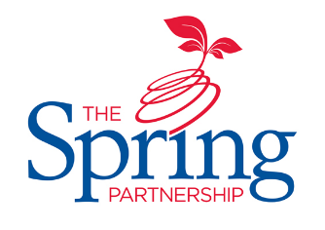


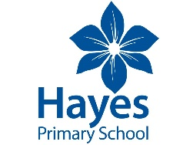
The Spring Partnership Trust

Home Learning Overview:
Year |Group: 2
Week Beginning: Monday 21st September
Subject | For week beginning:
Subject | - Resources needed | - Guidance (Part of home learning)
Maths | BBC Home Learning | Follow the lessons on place value on the White Rose  https://whiterosemaths.com/homelearning/year-2/week-1/  You can also explore the lessons on the BBC Home Learning website:  https://www.bbc.co.uk/bitesize/articles/z2k3p4j
Reading |  | Reading should happen daily for 15-20 minutes.
Spelling | Spelling Sets – on website | Your child can choose which spellings they wish to complete using their spelling sets (KS2). Children in KS1 will have spellings linked to their phonics learning sent on dojo.
Grammar | Year 2 – Grammar | Focus: Verbs  Watch the video – can you identify the verbs?  https://www.bbc.co.uk/bitesize/topics/zrqqtfr/articles/zpxhdxs
English | BBC Home Learning | Explore the lessons on the BBC Home Learning website:  https://www.bbc.co.uk/bitesize/collections/year-2-and-p3-english-topics/1
Times tables | See individual school plans | Practice your 2 and 10 times tables please
Science | Year 2 – Animals including humans. | Lesson 3 - WALT: ask questions to find out about human offspring and growth  Watch the videos which looks at how humans change as they get older and complete the online activities.  https://www.bbc.co.uk/bitesize/articles/zjppf4j  https://www.bbc.co.uk/bitesize/clips/zt7w2hv
History/ Geography | Year 2 Geography – Orienteering. | Lesson 3 - WALT: Understand map keys  Watch this video about maps  https://www.bbc.co.uk/teach/class-clips-video/geography-ks1--ks2-maps/zdwhpg8  Draw a map of your room or garden. Can you include a key?
Art/ D &T | Year 2 Art – Drawing  - Sketching materials | Lesson 3 – Practice our drawing skills  Follow this art lesson on BBC Home Learning - https://www.bbc.co.uk/bitesize/articles/z6g2xyc
PSHE |  | Lesson 3 – Managing Worries  Sometimes we feel sad or can have mixed emotions because of things happening in our lives. You might feel sad or cross that you can’t be at school at the moment. Watch this video about feelings and then create a picture of all the things you could do to help feel happier again. https://www.bbc.co.uk/bitesize/clips/zk2w2hv

