Year 2 Homework Menu - Spring Term
Reading
There are comprehensions for you to do each week. Make sure to mark it in your reading log so you get extra dojos.

DT/Art
Choose a recipe with your grown up and follow it to create a yummy dish. Take pictures and tell us what you think.

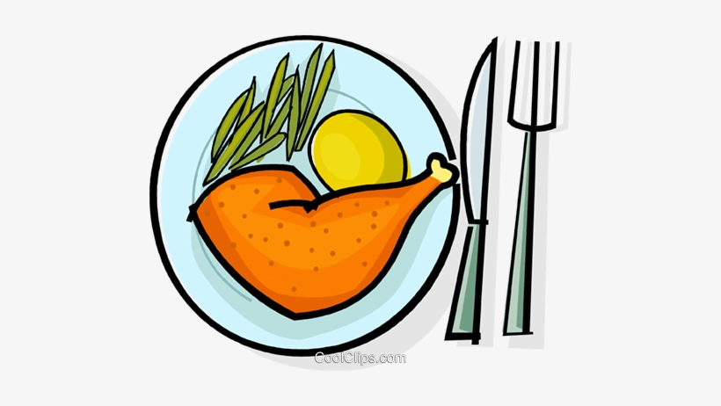
Maths
Maths worksheet will be uploaded weekly.

Also, remember to go on TT Rockstars.


Writing
Using the picture as a stimulus write a story about the picture. There are some extra activities to get you started.

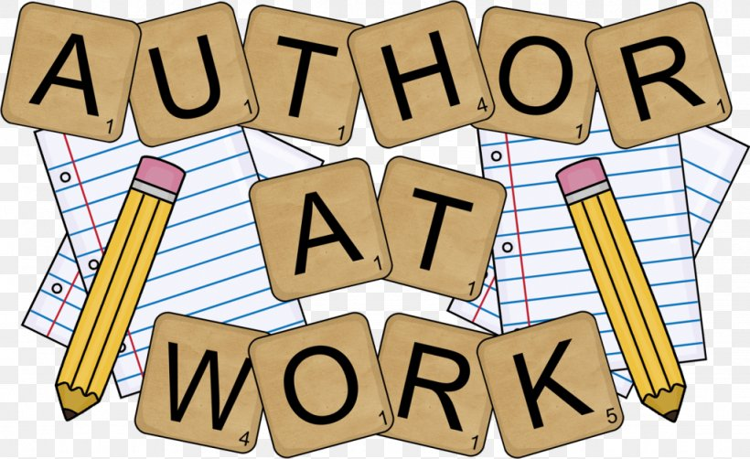
PHSE
Keep a diary for a week about the healthy choices you make and what you do to relax.



Geography Experience
Chose one city in the UK and create a fact file about it. Think about what can you see/do there? Are there any special celebrations? Are there any rivers or mountains?

Science
Go on a walk and find as many habitats as you can.

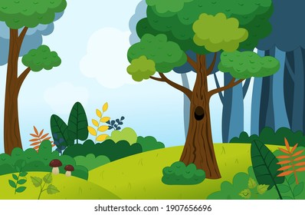
Speaking & Listening
Interview somebody about what it was like when they grew up? What toys did they play with? How did they travel? How did they talk to people?

Music
Use this link
https://www.youtube.com/watch?v=l-dYNttdgl0

Listen very carefully to the music and complete the tasks listed.

PE
Create a game that only involves one ball. Write down the rules and instructions on how to play. Maybe have a go at playing it with a grown up or sibling.


Bronze Award = 5 Silver Award = 8 Gold Award = 10 Platinum Award = 10 + 2 challenges

