Nursery | Autumn 1 | Autumn 2 | Spring 1 | Spring 2 |  | Summer 1 | Summer 2
Main Theme/Area of Learning  Key Texts/Books | Marvellous Me  - My first day at nursery  - Starting school  - I am too absolutely small for school  - The wolf who wouldn’t go to school  - A letter from your teacher  - Our class is a family  - Miss Plumberry  - The colour monster goes to school  - My family  - All about families  - We are all welcome  - Super duper you  - We’re all wonders  - Hey you!  - The Colour Monster  - In my heart  - The huge bag of worries  - The invisible string  - The feelings book  Autumn/Harvest -  (incl - non fiction)  - Olivers vegetables  Black History texts -  (incl - non fiction)  - Handa’s Surprise | Celebrations  Autumn -  (incl- Non fiction)  - Hovis the Hedgehog  - Owl babies  - We’re going on a leaf hunt  - Goodbye Summer, hello Autumn  - Because of an acorn  - The Scarecrows Wedding  - Let’s celebrate – special days around the world  - Festivals In Different Cultures Book Pack  Christmas texts -  (incl - non fiction)  - The Christmas story  - the Jolly Christmas postman | People Who Help Us  - Doctor Ted  - At the hospital  - Officer George  - People Who Help Us Series of books  - A superhero like you – Dr Ranj  - Usborne Jobs People do  - Busy People – Series Collection  - Topsy and Tim meet the police  - When I’m a Nurse | Nursery Rhymes  - Humpty Dumpty  - Incy Wincy  - 5 little Ducks  - Currant Buns  - Miss Polly  - 1,2,3,4,5 Once I caught a fish  - Old MacDonald |  | Minibeasts/Growing  - The Very Hungry Caterpillar-Eric Carle  - Little Red Hen-Jerry Pinkney  - Argh Spider-Lydia Monks  - Teeny Weeny Tadpole-Sheridin Cain  - What the Ladybird Heard-Julia Donaldson  - Superworm-Julia Donaldson  - Wiggling Worms at Work-non fiction-  - Errol’s Garden  - A Year Around  - the Great Oak  - The  - Extraordinary  - Gardener  - - The Life Cycle of  - a Chicken  - - Big Boys Cry  - - Toby is a Big Boy  - - Hundred Feet Tall  - Jack and the beanstalk | Keeping Healthy  - Healthy Wolf  - Sun Safety (Mr tumble)  - The very hungry caterpillar  - Olivers fruit salad/vegetables  - Supertato  - Handa’s surprise  - I will never not ever eat a tomato  - Try it  - Orange pear, apple bear  - Every night is pizza night  - Monsters don’t eat broccoli  - Dragon’s don’t eat tacos  - Baby goes to market  - Dim sum for everyone  - Spoon
Lines of Enquiry/Festivals and Celebrations/  Interests | - Initial Parent Consultations before return to Nursery  - World Peace Day (21st Sept)  - Harvest - food bank donations  - Black History (1st Oct – 31st Oct)  - Diwali (12th Oct)  - Autumn | - Nursery Parent Consultations  - Bonfire Night (Nov 5th)  - Remembrance Day (Nov 11th - Sunday 10th)  - Nursery Rhyme Week (13th - 17th Nov)  - Anti-Bullying Week (13th - 17th Nov)  - Road Safety Week (19 - 25th Nov)  - Children in Need (17th Nov)  - Christmas (25th Dec)  - Hanukkah (26th-2nd Jan) | - World Religion Day (16th Jan)  - Big Garden Bird Watch (26th Jan)  - Children’s Mental Health Week (5th-11th Feb)  - Chinese New Year (10th Feb – Year of the Dragon)  - Internet Safety Day (6th Feb)  - Pancake Day (13th Feb)  - Valentine’s Day (14th Feb)  - Winter | - World Book Day (7th March)  - Science Week (8-17th March)  - Holi (24th-25th March)  - Mother’s Day (10th March)  - Ramadan (10th March - 9th April)  - Vaisakhi (14th April)  - Easter (Sunday 31st March)  - World Earth Day (22nd April)  - Spring |  | - World Art Day (15th April)  - St. George’s Day (April 23rd)  - Eid (9th-10th April)  - National Sports Week (1st-7th May)  - GRTHM (1st June)  - World Mental Health Week (13th-20th May)  - World Bee Day (20th May)  - Children’s Gardening Week (25th May-2nd June)  - Planting beanstalks and plants, grass, flowers and vegetables  - Forest School | - Father’s Day (16th June)  - World music Day (21st June)  - Pride  - Marshmallows on campfire Graduation  - School pool  - National Sports Week  - Summer
Enrichment and Trips/Visits | - Library  - Scadbury woods | - Dentist Visit  - Library  - Church (Christingle making) | - Library  - Visitors in | - Library  - Author in |  | - Library  - Scadbury  - Christmas Tree Farm  - Tesco  - Theatre-What the ladybird heard?  - Coolings Garden Centre | - Library  - Swimming at Midfield
Communication and Language  (Prime Area)  To become a Confident Communicator.  Who can listen carefully in different situations, hold a conversation with peers and adults, ask relevant questions and use vocabulary to explain ideas and feelings. | *To be able to listen to simple stories and understand what is happening, with the help of the pictures.  *To be able to identify familiar objects and properties for practitioners when they are described. For example: ‘Hassan’s coat’, ‘blue car’, ‘shiny apple’.  *To be able to follow a three key-word instruction.  *To ask for help from a familiar adult.  *To initiate conversations with peers and adults. | *To be able to engage in stories and rhymes with props.  *To be able to join in with repetitive words and phrases.  *To sustain attention for short periods.  *To begin to use some new vocabulary in play.  *To understand simple questions e.g. ‘why did the ball move?’  *To be able to ask a question related to an area of their own interest.  *To share how they are feeling (using visual prompts if necessary). | *To be able to enjoy listening to longer stories and can recall much of what happens.  *To respond to more complex questions or instructions (E.g. a instruction that has two parts, such as “Get your coat and wait at the door”).  *To sing a large repertoire of songs and rhymes.  *To begin to understand basic prepositions. | *To know many rhymes, be able to talk about familiar books, and be able to retell story.  *To sustain concentration for longer periods of time.  *To talk to organise themselves in their play.  *To use a wider range of vocabulary in their play. |  | *To be able to join in with a group and listen to others patiently.  *To be able to turn take, showing awareness of others.  *To be able to talk about thoughts even when they disagree and can discuss this using words and actions. | *To be able to form clear sentences (of four to six words) and speak to a small audience.  *To understand and respond to more complex questions (e.g. who, what, why, when).  *To be able to move away from distractions when concentrating  *To begin to use tenses with some accuracy.
Personal, Social and Emotional Development  (Prime Area)  To become a Lifetime Learner.  To be an independent individual who can manage their own needs through the self-selection of activities and resources, follow the nursery rules, build upon existing knowledge and begin to challenge themselves as learners.  To become a Fantastic Friend.  Who can recognise and talk about their emotions, be kind, caring and helpful, show empathy and respect to others, work and play cooperatively demonstrating good self-regulation. | *To play with increasing confidence on their own and with other children- because they know their key person is nearby and available.  *To select and use activities and resources, with help when needed. This helps them to achieve a goal they have chosen, or one which is suggested to them.  *To be able to share their emotions using pictures and props. | *To be able to, with support talk about and manage their emotions using simple vocabulary such as ‘happy’, ‘sad’, ‘cross’ etc.  *To notice and ask questions about differences, such as skin colour, types of hair, gender, special needs and disabilities, and so on.  *To develop friendships with other children  *To be able to increasingly begin to follow rules, understanding why they are important. | *To begin to understand what it means to be responsible.  *To show more confidence in new social situations and with new experiences within the safety of their familiar environment.  *To be able to with support begin to compromise with their peers during low level conflict.  *To be able to show ‘effortful control’. For example, waiting for a turn and resisting the strong impulse to grab what they want or push their way to the front.  *To begin to find ways of regulating their emotions with support.  *To safely explore emotions beyond their normal range through play and stories. | *To be able to lead play and also to listen to the ideas of others.  *To be able to talk with others about how they are feeling and to begin to solve minor conflicts.  *To begin to brush their own teeth with support.  *To increasingly independent in meeting their own care needs, e.g. using the toilet, washing and drying their hands thoroughly.  *To begin to learn about some healthy food choices.  *To be able to share and turn take with peers. |  | *To be able to play with others for an extended period of time.  *To be able to show independence within the setting and can select activities and resources independently.  *To be able to follow the rules and know why they are important without the support of an adult.  *To understand what a community is and feel valued as part of the Nursery community. | *To be responsible and be confident to be part of my community.  *To be ready for new experiences like starting school.  *To solve low level conflict without the support of an adult.  * To be independent in meeting my own care needs, using the toilet, and wiping my bottom washing and drying my own hands.  *To be confident to share thoughts and feelings with peers and adults.
Physical Development  (Gross Motor)  (Prime Area) | *To be able to push along on a balance bike or trike using two feet.  *To climb steps using alternate feet.  *To stand on one leg and hold a pose for a game like musical statues.  *To use flags and streamers to develop large muscle movements. | *To use tools such as trowels and spades to fulfil a purpose.  *To collaborate with others to use large items such as wooden planks and blocks. | *To be able to ride a scooter, pushing along with one leg.  *To show a preference for a dominant hand/ foot.  To hop on one leg.  *To kick a large ball using their dominant foot. | *To become increasingly independent as they get dressed and undressed, for example, putting their own shoes and coat on.  *To be able to use and remember sequences and patterns of movements which are related to music and rhythm. |  | *To be able to ride a bike/ trike using pedals.  *To be able to eat independently and use a knife and fork.  *To begin to have an awareness of safety and manage their own risks. | *To be independent when dressing and undressing.  *To make healthy choices about food, drink, activity and tooth brushing.  *To throw and catch a large ball with some accuracy.
Literacy/Phonics  (Fine Motor)  (Specific Area)  To become a Brilliant Bookworm.  With well-developed concepts of print and spoken word, placing great emphasis on enjoying familiar and traditional stories and rhymes. | The main focus in Nursery is being a 'talk-a-lot, read-a-lot' setting. Reading stories, singing and rhymes are incorporated throughout the day and help to develop language. Quality talk is prioritised and a communication-friendly environment enables children to develop important communication and language skills. Phase 1 of a phonics teaching programme is used to support the language and literacy of our Nursery children before moving onto the Read, Write, Inc programme.  Children develop their pre-phonics skills by exploring environmental sounds, musical instruments, body percussion, rhythm and rhyme, voice sounds and alliteration.  In the summer term, we move on to following the Read Write Inc programme of phonics to develop awareness of letter sounds. This focusses primarily on using 'Fred Talk' to promote oral blending.  We enjoy many books throughout our day, giving children opportunities to think about how stories are structured, to make predictions about what might happen next and to retell and act out stories.  Here at Midfield, we understand the progression of skills which lead to writing; so activities to build both gross and fine motor skills are always available, such as digging in the mud area, daily dough disco and large scale mark-making with paints and chalks outside.
 | Pre-Requisite Schemes for Emergent Reading  Oral language and vocabulary  Choosing  (Selecting books, props for rhymes)  Matching  (Objects, colours, pictures (snap)– to - letters  and sounds)  Ordering  (By size, shade – to - scanning from left to right – & making cvc words with cut out letters)  Sequencing  (Daily routines cards, popular stories such as the Very Hungry Caterpillar and We’re going on a bear hunt. Story boarding/sequencing cards)  Auditory discrimination. – different sounds  (Loud to quiet, animal sounds, sounds in the environment – to – phonic sounds)  Recognising text carries meaning  (Logos, names, signs, labels – to - books)  Visual discrimination of symbols  (By shape, colour, size –to- letters) |  |  |  | Pre-Requisite Schemes for Emergent Writing  Oral language and vocabulary  Horizontal & vertical trajectory scheme  (Drawing crosses, grids)  Circles and lines  (Semi-circles are used as features, parts of bodies and other objects.: e.g. Smiles, eyebrows, ears, rainbows and umbrellas – to - parts of letters of the alphabet).  Rotating scheme  (Drawing spirals, circles – to- tracing around shapes in an anti-clockwise direction)  Choosing  (One-handed tools, paper, crayons, painting, story books – to - shape/letter stencils)  Matching  (Objects, colours, pictures (snap)– to - letters  and sounds)  Ordering  (By size, shade – to - scanning from left to right – & making cvc words with cut out letters-)  Sequencing  (Daily routines cards, popular stories such as the Very Hungry Caterpillar and We’re going on a bear hunt. Story boarding/sequencing cards)  Auditory discrimination. – different sounds  (Loud to quiet, animal sounds, sounds in the environment  to – phonic sounds and rhyming words)  Recognising text  (Logos, names, signs, labels – to - books)  Visual discrimination of symbols  (By shape, colour, size –to- letters)
 | *Sing songs and say rhymes independently, for example, singing whilst playing.  *Repeat words and phrases from familiar stories.  *Have favourite books and seeks them out, to share with an adult, with another child, or to look at alone.  * To understand that print has meaning.  *To understand page sequencing.  *Enjoy drawing freely.  *Pre-Phonic Skills – Tune into environmental Sounds. | *To understand that we read text from left to right and top to bottom (in English).  *Add some marks to their drawings, which they give meaning to. For example: “That says mummy.”  * Join in with songs and rhymes, copying sounds, rhythms, tunes and tempo.  *Pre-Phonic Skills – Tune into instrumental sounds and start to use body percussion. | *To understand that print has different purposes.  * Add some marks to their drawings, which they give meaning to. For example: “That says mummy.”  *Engage in extended conversations about stories, learning new vocabulary.  *Pre-Phonic Skills – To spot and suggest rhymes. | * To copy and repeat action and sound rhymes.  *To clap out syllables in a word.  *To recognises their own name in print.  *Hear and says the first sound in a word when you say the word.  *Pre-Phonic Skills – To spot and suggest rhyme and alliteration. |  | *To be able to name some of the features of a book.  *To know that stories have a beginning and ending.  *To make predictions about events in a story.  *To begin forming familiar letter in their name.  *Pre-Phonics Skills – Recognise words with the same initial sound. Introduce ‘Fred Talk’ (oral segmenting and blending). | *To write some or all of my name  *To write some letters accurately  *To talk about the places and characters and events in stories.  *To recall familiar stories.  *To be able to suggest rhyming CVC words.  *Pre-Phonic Skills – Develop ‘Fred Talk’ skills (oral segmenting and blending).  Introduction of RWI Strong Start for children who have a very strong pre-phonic knowledge.
Mathematics  (Specific Area)  To become a Master of Maths.  Who can show a deep understanding of numbers to ten, recognise patterns within the number system, subitise, compare quantities and recall number bonds to five. | We explore maths daily through play. This includes number songs and rhymes, shape recognition within our environment, counting with accuracy through building with blocks and by looking at measure and capacity by playing with sand, water and mud. Mathematical language is modelled by the adults in play.
 | Pre-Requisite Schemes for Emergent Addition  Matching  (Objects/materials – noticing when something is the same)  Counting  (Counting – in songs, rhymes, books, and counting objects)  Tallying/Recording  Grading  (By length/height to recognise increases)  Direct to addition  Matching  (Loose quantities to fixed numbers in sequence)  Sequencing  (Number symbols 1-5/1-10, etc)  Ordering/Sequencing  (Loose quantities to loose number symbols)  Counting-on fixed quantities  Counting-on with loose quantities  Counting on and recording answer  (written or finding number symbol)  Addition symbol recognition |  |  |  | Pre-Requisite Schemes for Emergent Addition  Dynamic vertical and horizontal trajectory  (Whole body/mark-making)  Enclosing & containing schemes  (Covering objects with materials, placing objects inside containers)  One to one correspondence/Matching  (Matching different sized objects/containers)  Connecting, Constructing & Counting  (Placing blocks on top of one another or in a line and counting them)  Estimating  (More or less/taller or smaller, wider or thinner, longer or shorter).  Grading  (Different lengths/heights/Dimensions/Volume)  Tallying  One to one correspondence of number symbol and quantity /Recording  Recording  (Differences in height, length and volume.
 | *Perceptually subitise to 3 (cardinality of a set can be accessed without counting)  *See number patterns to 3.  *Conservation of number (recognising different forms of a number to 3)  *Counts up to three objects by saying one number name for each item (accurate 1:1 counting).  * Take part in counting songs and rhymes.  *Explore and select shapes to fulfil a purpose.  *Talk about and identify patterns around them. | * Recognise some numerals of personal significance.  * Know that the last number counted gives the total.  *Perceptually subitise to 5 (cardinality of a set can be accessed without counting)  *See number patterns to 5.  *Conservation of number (recognising different forms of a number to 5)  *Counts up to five objects by saying one number name for each item (accurate 1:1 counting).  * Recognises and names common 2d shapes.  *Copy an AB pattern.  *Understand and use spatial words in play (in, on, under, over, up, down). | *Recognises numerals 0 to 3.  *Perceptually subitise to 6 (cardinality of a set can be accessed without counting)  *See number patterns to 6.  *Conservation of number (recognising different forms of a number to 6)  *Counts up to six objects by saying one number name for each item (accurate 1:1 counting).  *Play and construct utilising the properties of shape (e.g. circle for a wheel as it can roll, square for a window as it has straight sides etc.).  *Continue an AB pattern.  *Understand and use words to discuss routes and location in play (in front of, behind, through, opposite, next to, beside). | *Recognises numerals 0 to 6.  *Perceptually subitise to 7 (cardinality of a set can be accessed without counting)  *See number patterns to 7.  *Conservation of number (recognising different forms of a number to 7)  *Counts up to seven objects by saying one number name for each item (accurate 1:1 counting).  *Begin to recognise similarities and differences between 2D and 3D shapes.  *Create an AB pattern.  *Identify groups with the same/ equal number of items and check by matching/ subitising/ counting.  *Make comparisons relating to size and length. |  | *Recognises numerals 0 to 8.  *Perceptually subitise to 8 (cardinality of a set can be accessed without counting)  *See number patterns to 8.  *Conservation of number (recognising different forms of a number to 8)  *Counts up to eight objects by saying one number name for each item (accurate 1:1 counting).  *Begin to conceptually subitise (talk about numbers within numbers) to 3.  *Begin to explore shapes using some informal and mathematical language: ‘sides’, ‘corners’; ‘straight’, ‘flat’, ‘round’.  *Identifying an error in an AB pattern.  *Compare collections and talk about more than and less than.  *Make comparisons relating to capacity. | *Recognises numerals 0 to 10.  *Perceptually subitise to 10 (cardinality of a set can be accessed without counting)  *See number patterns to 10.  *Conservation of number (recognising different forms of a number to 10)  *Counts up to ten objects and beyond by saying one number name for each item (accurate 1:1 counting).  *Begin to conceptually subitise (talk about numbers within numbers) to 5.  *Recognises and names some common 2D and 3D shapes and can talk about them in simple terms (e.g. the sphere is round it can roll).  *Identifying the unit of repeat in an AB pattern.  *Is able to order their daily routine.  *Make comparisons relating to weight.
Understanding the World  (Specific Area)  To become an Ambassador of Nature.  Who can show curiosity about the world around them, who can look after the community and care for the environment. | *Understand how their family is made up.  *Notice similarities and differences between people.  *Show curiosity about the natural world around them. | *Make connections between the features of their family and other families.  *Explore with their senses and talk about what they experience.  *Begin to respect our nursery setting and the natural environment. | *Celebrate the differences between themselves and their peers.  *Explore and investigate natural materials.  *Understand the need to care for all living things.  *Explore the changes they notice around them and in their play. | *Plant seeds and care for growing plants.  *Be able to talk about some features of a lifecycle.  *Discuss changes over time.  *Be confident taking risks as they explore the local environment. |  | *Discuss their observations of the natural environment.  *Make predictions about what they think will happen.  *Explore how things work (e.g. the toys that they play with). | *Explore forces including floating and sinking, pushing and pulling, and magnetic attraction.  *Know that there are different countries in the world and talk about the differences they have experienced or seen.
Expressive Arts and Design  (Fine Motor)  (Specific Area) | *Start to make marks intentionally, expressing some meaning.  *Explore paint, using a brush.  * Enjoy and take part in action songs.  *Explore different materials, using all their senses to investigate them. *Use their imagination as they consider what they can do with different materials.  *Make simple models which express their ideas.  *Holds scissors (often with both hands, learning to open and close blades) | *Develop their ideas by giving meaning to the marks that they make/ items they create.  *Explore different ways to join materials.  *Begin to remember familiar songs.  *Start to develop pretend play, pretending that one object represents the other.  *Holds scissors to experiment with snipping paper. | *Explore a wider range of mark making and creative materials and offer suggestions of what they will make.  *Create closed shapes with continuous lines, and begin to use these shapes to represent objects.  *Explore colour and colour mixing.  *Experiment with different ways of playing instruments.  *Holds scissors to snip paper moving forward. | *Begin to develop more complex stories in play using small world equipment like animal sets, dolls and dolls houses etc.  *Begin to make imaginative and complex ‘small worlds’ with a variety of resources.  *Draw with increasing detail, such as adding facial features to a circle for a face.  *Listen with increased attention to sounds.  *Uses a helping hand to hold and help guide paper when cutting using scissors. |  | *Play instruments with increasing control.  *Mix paints together to make new colours, and begin to talk about the different shades such as light and dark  *Show different emotions in their drawings and paintings, like happiness, sadness, fear etc. *Respond to what they have heard, expressing their thoughts and feelings  *Able to cut a straight line using scissors. | *Remember and sing whole songs.  *Safely uses and explores a variety of different tools such as peelers, hammers and scissors.  *Begin to suggest alternatives if their ideas don’t work, they can choose something else or change the way they do something.  *Draws/ constructs for a purpose using detail and can speak about their drawing/ design.  *Able to cut a curved line using scissors.
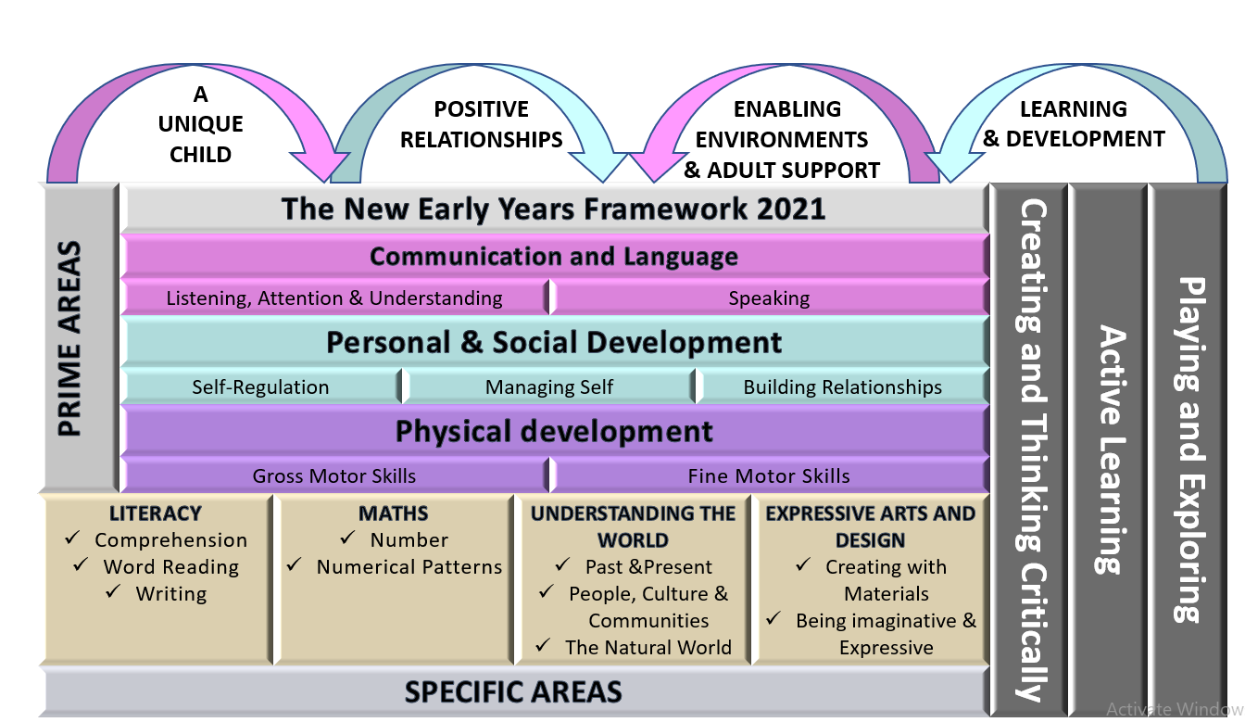
Characteristics of Effective Learning:
Playing and exploring: - Children investigate and experience things, and ‘have a go’. Children who actively participate in their own play develop a larger store of information and experiences to draw on which positively supports their learning
Active learning: - Children concentrate and keep on trying if they encounter difficulties. They are proud of their own achievements. For children to develop into self-regulating, lifelong learners they are required to take ownership, accept challenges and learn persistence.
Creating and thinking critically: - Children develop their own ideas and make links between these ideas. They think flexibly and rationally, drawing on previous experiences which help them to solve problems and reach conclusions.
4 Overarching Principles:
Unique Child: Every child is unique and has the potential to be resilient, capable, confident and self-assured.
Positive Relationships: Children flourish with warm, strong & positive partnerships between all staff and parents/carers. This promotes independence across the EYFS curriculum. Children and practitioners are NOT alone – embrace each community.
Enabling environments: Children learn and develop well in safe and secure environments where routines are established and where adults respond to their individual needs and passions and help them to build upon their learning over time.
Learning and Development: Children develop and learn at different rates (not in different ways as it stated 2017). We must be aware of children who need greater support than others.
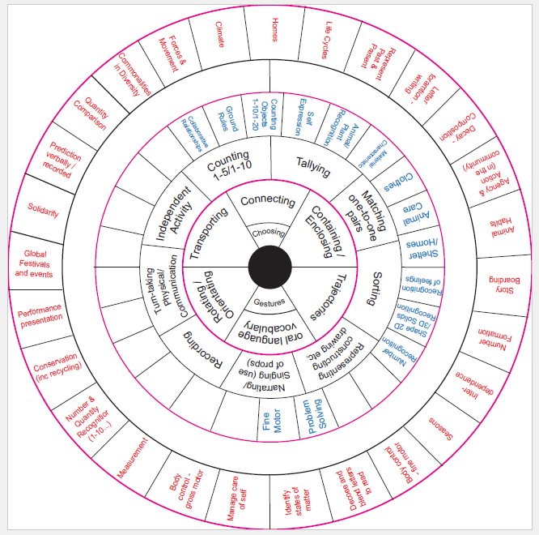
Schema Play Curriculum Wheel

