Pupil Premium Strategy Statement
Midfield Primary School
2024-2025

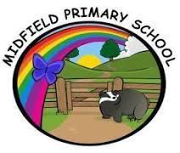
This statement details our school’s use of pupil premium (and recovery premium) funding to help improve the attainment of our disadvantaged pupils.
It outlines our pupil premium strategy, how we intend to spend the funding in this academic year and the outcomes for disadvantaged pupils last academic year.
This document should be read in conjunction with our Pupil Premium Rationale for 2024-2025 which expands on our Pupil Premium Intent.
Levels of Deprivation
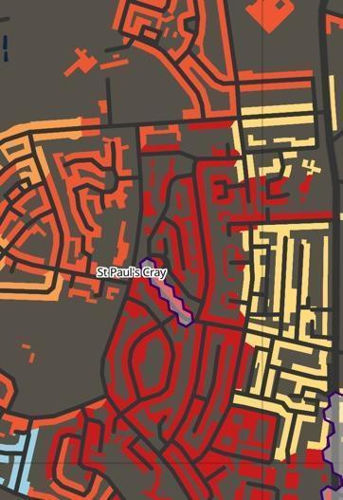
Midfield Primary School serves a significantly deprived community with an IDACI code of 3993 (index of multiple deprivation), the second most deprived decile nationally. It falls within a pocket of deprivation within an otherwise relatively affluent area within the London Borough of Bromley.

This image is taken from the CDRC IDACI Mapmaker (2024) and visually demonstrates the significant level of deprivation directly surrounding the school. Red is the most deprived decile nationally.

School overview
Detail | Data
Number of pupils in school | 461
Proportion (%) of pupil premium eligible pupils | 24% (109 pupils)
Academic year/years that our current pupil premium strategy plan covers (3 year plans are recommended) | 2024-2027  (Y1 of Strategy)
Date this statement was published | October 2024
Date on which it will be reviewed | July 2025
Statement authorised by | Gulcin Sesli and Corinne Sheehan (Spring Partnership Trust)
Pupil Premium Lead | Dan Osborn
Trustee Lead | Alan Blount

Funding overview
Detail | Amount
Pupil premium funding allocation this academic year | £146,528
Pupil Premium funding carried forward from previous years (enter £0 if not applicable) | £0  £0
Total budget for this academic year  If your school is an academy in a trust that pools this funding, state the amount available to your school this academic year | £146,528

Part A: Pupil premium strategy plan

Statement of intent
At Midfield, we believe that all pupils should be given the opportunity to achieve their full potential, regardless of their background, race, gender or socio-economic circumstances. We are passionate that all children leave Midfield with the necessary skills to access the next part of their learning journey in preparation for them to contribute to society regardless of their starting point.
This year we have seen an increased number of children with SEND entering nursery, YR and across the school. An increase in children with multiple vulnerabilities means it is essential we identify barriers.
Research shows that pupils from disadvantaged backgrounds underachieve compared to their non-disadvantaged peers. Pupil premium is provided to enable these pupils to be supported to reach their potential. The Government has used pupils who have been eligible for free school meals (FSM) at any point in the last six years (also known as Ever 6 FSM), looked after children and children whose parents are currently serving in the armed forces as eligibility criteria for the pupil premium, and have provided a fixed amount of money for schools per pupil based on these. Acting early and creating an enabling environment allows children to catch up sooner, which makes more economic sense.
The areas of academia, wellbeing, physical health, social, moral, spiritual and cultural are all equally important to ensure each one of our children receives the best start in life and are able to access school fully. We use our Pupil Premium funding to achieve these goals by:
∙ Ensuring that all children have access to quality first teaching and learning across the school.
∙ Focus on early intervention, which identifies need as early as possible, providing targeted or specialist support
∙ Ensuring that spending is directly linked to closing gaps in attainment.
∙Developing assessment system to identify gaps in learning.
∙ We have robust monitoring to ensure that all children are engaged, supported and challenged in order to make excellent progress
∙ Making use of our own data to expand existing interventions
∙ Making use of research when evaluating interventions and considering the implementation of new interventions
∙ Promoting reading through engaging text
∙ To accelerate the progress of disadvantaged learners through the development of Oracy 21
∙ Providing opportunities and ‘life-experiences’ which the children might not otherwise have access to. These include making use of our outdoor learning environment, trips, clubs and the Outdoor Learning Programme.
∙ Providing opportunities to attend extra-curricular activities and to enjoy educational trips and visits, irrespective of family income.
∙ Promoting positive wellbeing, nurturing approach and positive restorative behaviour across the school to support an environment which empowers all children to make excellent progress.
∙ Supporting pupils, parents and carers emotionally and in times of hardship in order to help them to deal with the pressures of modern life. This may involve food parcels, subsidised uniform or counselling sessions for pupils and their families with emotional needs.

Challenges
This details the key challenges to achievement that we have identified among our disadvantaged pupils.
Challenge number | Detail of challenge
1 | Pupil premium children have lower oral, language skills and reading skills than other pupils.
2 | There is a strong link between Pupil Premium and SEND. Many of our Pupil Premium children are also on the school’s SEND register. Increased number of children with undiagnosed SEND, particularly SEMH presentations.
3 | Pupil premium children often have significant social and emotional needs and fewer strategies for maintaining positive mental and physical health.
4 | There are higher levels of parental anxiety, mental ill health, domestic violence, financial pressures
5 | The attendance and punctuality of pupil premium children is lower than that of non-pupil premium children.
6 | Pupil Premium children are more likely to have fewer opportunities outside of school, lower aspiration for their futures and lack resilience required to develop both learning and independence skills

Intended outcomes
This explains the outcomes we are aiming for by the end of our current strategy plan, and how we will measure whether they have been achieved.
Intended outcome | Success criteria
- Improved oral language and early reading skills for Pupil Premium children. | The gap between disadvantaged and their peers will narrow and this will be evident in all statutory testing outcomes.  By the end of 2027 disadvantaged pupils will be achieving as well as their non-disadvantaged peers.
- SEND children will make good progress from their starting points, achieving their full potential through high quality teaching with staff skilled at using adaptive teaching to secure positive outcomes. | Additional barriers for individuals are identified by those who know them best, class teachers. Data is then used to inform bespoke provision, strategies and resources to secure progress linked to their SEN Passports or EHC plans.  Early identification and SEN pathways enable children with the most complex needs to be supported with the provision needed to engage in learning and progress.
- For all children to have the ability to self regulate. | Pupils will have the ability to identify with their mental health, emotions and engage in self-regulation strategies to take appropriate next steps to address
- Improved attendance and punctuality for Pupil Premium Children to make sure that it is above national averages | The gap in attendance figures between disadvantaged pupils and their peers will narrow by the end of 2025 and be in line with national attendance figures for disadvantaged groups. Robust support is in place to reduce the number of pupils considered to be Persistent Absentees. By 2026, pupils eligible for pupil premium will be in line with their peers.

Activity in this academic year
This details how we intend to spend our pupil premium (and recovery premium) funding this academic year to address the challenges listed above.

Teaching (for example, CPD, recruitment and retention)
Budgeted cost: £17,428
Activity | Evidence that supports this approach | Challenge number(s) addressed
The embedding of  Oracy practices  across the school to support the develop of children’s ability to learn through talk. | The Oracy Skills framework provide the benchmark that can used as diagnostic tool to assess children’s progress in their development of Oracy skills. Research from the EEF states that oral language approaches have a high impact on pupil outcomes of 6 months additional progress. | 1, 3, 6
Improved  development of  phonics and early  reading.  Fresh Start  programme delivered to children in Years 3,4,5 and 6 | Phonics Research shows (EEF) that systematic teaching of phonics is effective in in supporting younger readers to master the basics of reading, with an average impact of additional 4 months’ progress | 1, 3, 6
Whole school re  focus on  metacognition in the classroom; training, monitoring and  evaluation | Audits and reviews indicate that pupils are less confident in their learning and rely too heavily on their teacher. Metacognition strategies empower our children to learn how to learn. These approaches alongside self regulation have been shown to have consistently high levels of impact and aid increased attainment. | 1, 3, 6
SENCO to support early identification of learning needs in EYFS. SENCO to guide staff in adapting provision to reduce the SEN barrier. | Previous work within school shows that early interventions increases the opportunity for the child’s needs to be met and to make appropriate progress | 2, 3, 4
Develop the mindfulness and well being working party (Midfield United) to enable staff to discuss and develop practices to support well-being and resilience. | Research undertaken by the Mindfulness in Schools Project demonstrate the benefits and  applications of mindfulness in school. | 3, 4, 6
Create increased opportunities for children to develop skills and interests across the curriculum, encouraging PP pupils to enjoy opportunities they may otherwise not get the opportunity to do. Bexley Music first access expanded. | There is intrinsic value in teaching pupils creative and performance skills and ensuring disadvantaged pupils access a rich and stimulating arts education. Arts participation may be delivered within the core curriculum, or through extra-curricular or cultural trips which can be subject to financial barriers for pupils from deprived backgrounds.  EEF research demonstrates that Arts Participation leads to an impact of +3 months progress. | 6

Targeted academic support (for example, tutoring, one-to-one support, structured interventions)
Budgeted cost: £70,530
Activity | Evidence that supports this approach | Challenge number(s) addressed
Additional booster group sessions in small group sizes for marginal PP children  delivered. | EEF Research shows that  Tutoring is one of the most effective tools for recovering lost education (+4 months). Tuition is most effective when it is linked to classroom teaching.  Regular assessment and monitoring ensures that children remain on track and make progress. Small group sizes lead to better outcomes for pupils. | 1, 2, 6
Children who fall well below age  expectations are  provided with small group support during math and English  lessons to cater for specific needs using PIXL diagnose,  Therapy test and  review model | EEF Research  Small group tuition has an average impact of four months’ additional progress over the course of a year.  Small group tuition is most likely to be effective if it is targeted at pupils’ specific needs. Diagnostic  assessment can be used to assess the best way to target support. | 1, 2
Forensic Level Assessment systems allow for bespoke and targeted interventions specific to individual needs including learners with SENd. | Bespoke data systems enable high quality teaching assistant interventions and have a demonstrable impact on small-group tuition with a data-led approach. This is reinforced on the EEF Teaching and Learning toolkit which highlights TA Interventions and small group tuition as +4 progress indications for both. | 1, 2
Additional classroom support. With specific teachers focused on children falling well below age  expectations this  enables teaching assistants and ISA’s within the class to  focus their support on children who are in the class setting | EEF Research  Where teaching assistants are employed in an effective manner they can make a significant impact to the outcomes in the class. | 1, 6
Additional booster  classes delivered  twice per week after school in years 5 and 6 to targeted children with specific gaps identified by teachers | EEF Research  Small group tuition has an average impact of four months’ additional progress over the course of a year.  Small group tuition is most likely to be effective if it is targeted at pupils’ specific needs. Diagnostic  assessment can be used to assess the best way to target support. | 1, 2, 6
Teaching Assistant to implement the  Nuffield Early  Learning Language intervention (NELI) with EYFS and Y1  children to improve children’s language and early literacy  skills | Research demonstrates that pupils who participate in NELI make on average 3 months of additional progress in language. | 1, 3

Wider strategies (for example, related to attendance, behaviour, wellbeing)
Budgeted cost: £ £58,569.99
Activity | Evidence that supports this approach | Challenge number(s) addressed
Pupils are given opportunities to embrace immersive learning experiences they can connect to improving knowledge and skills in Social and Emotional Learning. As a result children can provide further context to their learning and to themselves within the wider world. | Evidence suggests that children from disadvantaged backgrounds have, on average, weaker SEL skills at all ages than their more affluent peers. These skills are likely to influence a range of outcomes for pupils: lower SEL skills are linked with poorer mental health and lower academic attainment.  SEL interventions in education are shown to improve SEL skills and are therefore likely to support disadvantaged pupils to understand and engage in healthy relationships with peers and emotional self-regulation, both of which may subsequently increase academic attainment.  EEF + 4 Months. | 2, 3, 6
Children are supported with their mental  wellbeing. School  provides extensive  pastoral support  including early morning drop in support group meetings, Paws B,  Counselling, One to  one direct work. They have access to counselling, and PIT stop sessions enabling improved access to the curriculum which leads to positive outcomes in progress and attainment. | The high degree of support for children with social and emotional needs has long been a feature of the school's practice and ethos. The work undertaken not only supports the children but also builds a positive culture for parental engagement which EEF research identifies as positive with up to +4 months progress made by pupils. The support provided strengthens pupils ability to self-regulate and forms part of the strategy and interventions offered which research suggests provides up to +7 months progress. Behaviour interventions are also included offering +4 months. | 3, 5, 6
To increase the  pastoral teaching  team to re build the provision supporting the emotional needs | Pastoral support teaching offers a combination of different approaches recommended and recognised by the EEF. This includes mentoring which offers +2 months progress, along with social and emotional learning interventions offering +4 months of learning. | 2, 3, 4, 5
Pupils from disadvantaged backgrounds will have financial barriers removed enabling them to participate fully in education visits, residentials and other opportunities | By removing these financial barriers, pupils eligible for pupil premium will be able to participate more fully in co-educational experiences providing them with new learning opportunities and experiences which gives them more cultural capital to draw upon which improves not only their personal development, but their academic abilities too. (e.g. writing because they have real-life experiences to draw upon). | 6
Specific resources purchased to meet the needs of individual pupil premium children (teaching and learning resources linked to barriers and participation). | By making the learning environment more accessible for individuals, they are able to contribute and access the curriculum to a far better extent leading to improved outcomes and increased progress. | 1, 2, 3

Total budgeted cost: £ 146,528

Part B: Review of the previous academic year 2023-2024

Outcomes for disadvantaged pupils
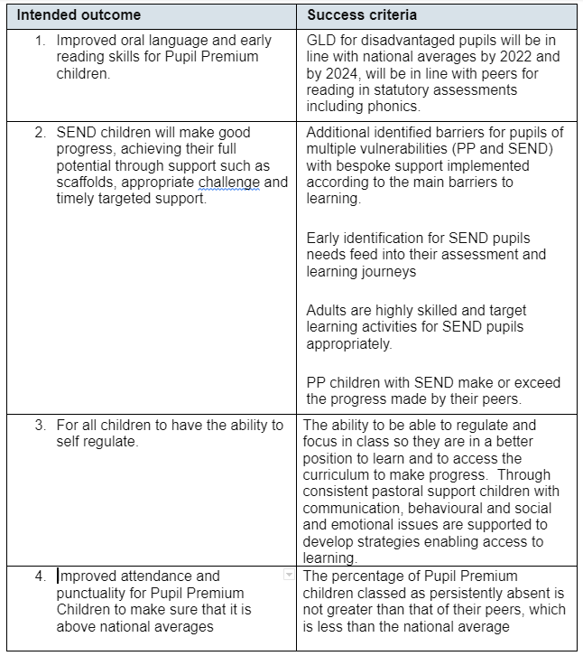
1. Improved Oral Language and early reading skills for pupil premium children.
Review:
GLD in Reception was above national average at 68%. Of the 18 children who did not achieve the GLD, 13 are on the SEN register and have a range of complex needs. 2 additional children were in year transfers. These children did not achieve GLD but made significant progress from their starting points. All children made good progress from their starting points and received interventions to support their progress. Improved Oral Language and Early Reading Skills are supported by careful implementation of the Read, Write Inc phonics scheme, RWI Strong Start, Nuffield Early Language Interventions, Talk Tables, Oracy, Speech and Language interventions and specialist support. Baseline assessments showed 17% of Pupil Premium children on track to achieve the ELG for reading, this increased to 40% at the end of the academic year. Phonics data showed poor phonic awareness at baseline but children made significant progress across the year. Improved outcomes mean that all children are now working at Ditty Level and above. A continued focus on Oral Language and Reading Skills will be in place for 2023/24 including the introduction of Drawing Club to further improve outcomes.
2. SEND children will make good progress, achieving their full potential through supports such as scaffolds, appropriate challenges and targeted support
Review: The impact of the strategies undertaken to develop the SEND provision has been significant and already in 2024, the school is far better equipped in ensuring early identification of pupils with SEND needs. The SEN Team are included in pupil progress meetings and staff are more aware of personalised targets linked to EHC and SEN Support Plans. The introduction of the engagement model for our non-subject specific learners in our ARPs has required a lot of input and training. CPD has been pivotol. In order to achieve the longer term targets by 2027, the systems and processes that have been introduced have now got to be developed further and embedded.
3. For all children to have the ability to self-regulate.
Review: This long term goal is one that the school has made significant whole-school progress on and strategies embraced through training opportunities and new initiatives has meant that Zones of Regulation is embedded across the school and visible in every classroom. There are some pupil premium children who are in need of bespoke consistent behaviour support plans and therefore their ability to self-regulate requires a different type of planned and targeted response. We have looked at behaviour interventions from the EEF guidance and will be looking to expand on the ZOR during this next academic year; increasing and further developing our PIT Stop provisions to ensure that holistic needs are met by adults who understand the complexities of individuals' circumstances. This target is on track to be achieved and embedded by 2026.
4. Improve attendance and punctuality for Pupil Premium children to make sure it is above national averages.
Review: Many of the strategies implemented to achieve this target demonstrated positive impact for individuals, particularly the early identification of children with emotional school based avoidance (ESBA) which increased following the pandemic as an increasing number of children presented with social and emotional mental health difficulties affecting school attendance. It was underestimated to what extent the wider support and strategies would be needed and this needs to become a far greater focus as we move forward with the new revised 3 year strategy in 2024-2025. if we are to achieve the target of achieving above national averages (in comparison to disadvantaged national statistics) for attendance by 2025. Tackling wellbeing, attendance, behaviour and multiple vulnerabilities remains one of the biggest challenges and therefore funding next year will need to place a greater emphasis on this area of the PP 3 year strategy.

Externally provided programmes
Please include the names of any non-DfE programmes that you used your pupil premium (or recovery premium) to fund in the previous academic year.
Programme | Provider
Nuffield Early Language Intervention (NELI) | Nuffield Foundation
Read, Write, Inc.and Fresh Start | Ruth Miskin
PiXL | Partners in Excellence
Oracy | Voice 21

